GREAT NEWS FOR PEOPLE IN SOUTH NORMANTON AND PINXTON

Release (Financial) Charitable Trust is a local charity based in South Normanton, set up in 2005 to help people with money worries, and provides free confidential money/debt advice to people in South Normanton, Pinxton and surrounding villages.

Especially at this time of austerity and welfare reform changes there are many people who are struggling to make ends meet. So as well as working with them to resolve their debt issues we support people in being educated and equipped to make informed choices in how to handle their finances and related issues, going forward.

We have developed a ‘Budget Buddy’ mentoring system to improve the service and support people receive - as it is clear that the provision of professional money advice needs to respond to the reality that a neat pattern of indebtedness, followed by advice and becoming debt-free, is rare - the Joseph Rowntree Charitable Trust in June 2010 (Credit and Debt in Low Income Families, Chris Dearden et al, June 2010). This report also recommends that support over a longer period including ongoing contact by telephone would be both beneficial and cost-effective.

This is the approach we take. We are committed to working in the round and supporting people to not only resolve/negotiate immediate crisis situations, but work with them to address a wide range of associated issues and to improve their skills, confidence and capacity to better manage their finances and other areas of life in the future.

Recently we are delighted to have been awarded grants from various amounts and time period from, The Henry Smith Charity, Trusthouse Charitable Trust and LloydsTSB Foundation, to continue to deliver our life-changing services.

To access our services, people just need to turn up at The Cyber Cafe in South Normanton, between 10am and 2pm, each Wednesday.

At this weekly drop-in (no appointment needed), we assess people’s needs and commence supporting them. Our friendly, experienced and approachable team will help and support people
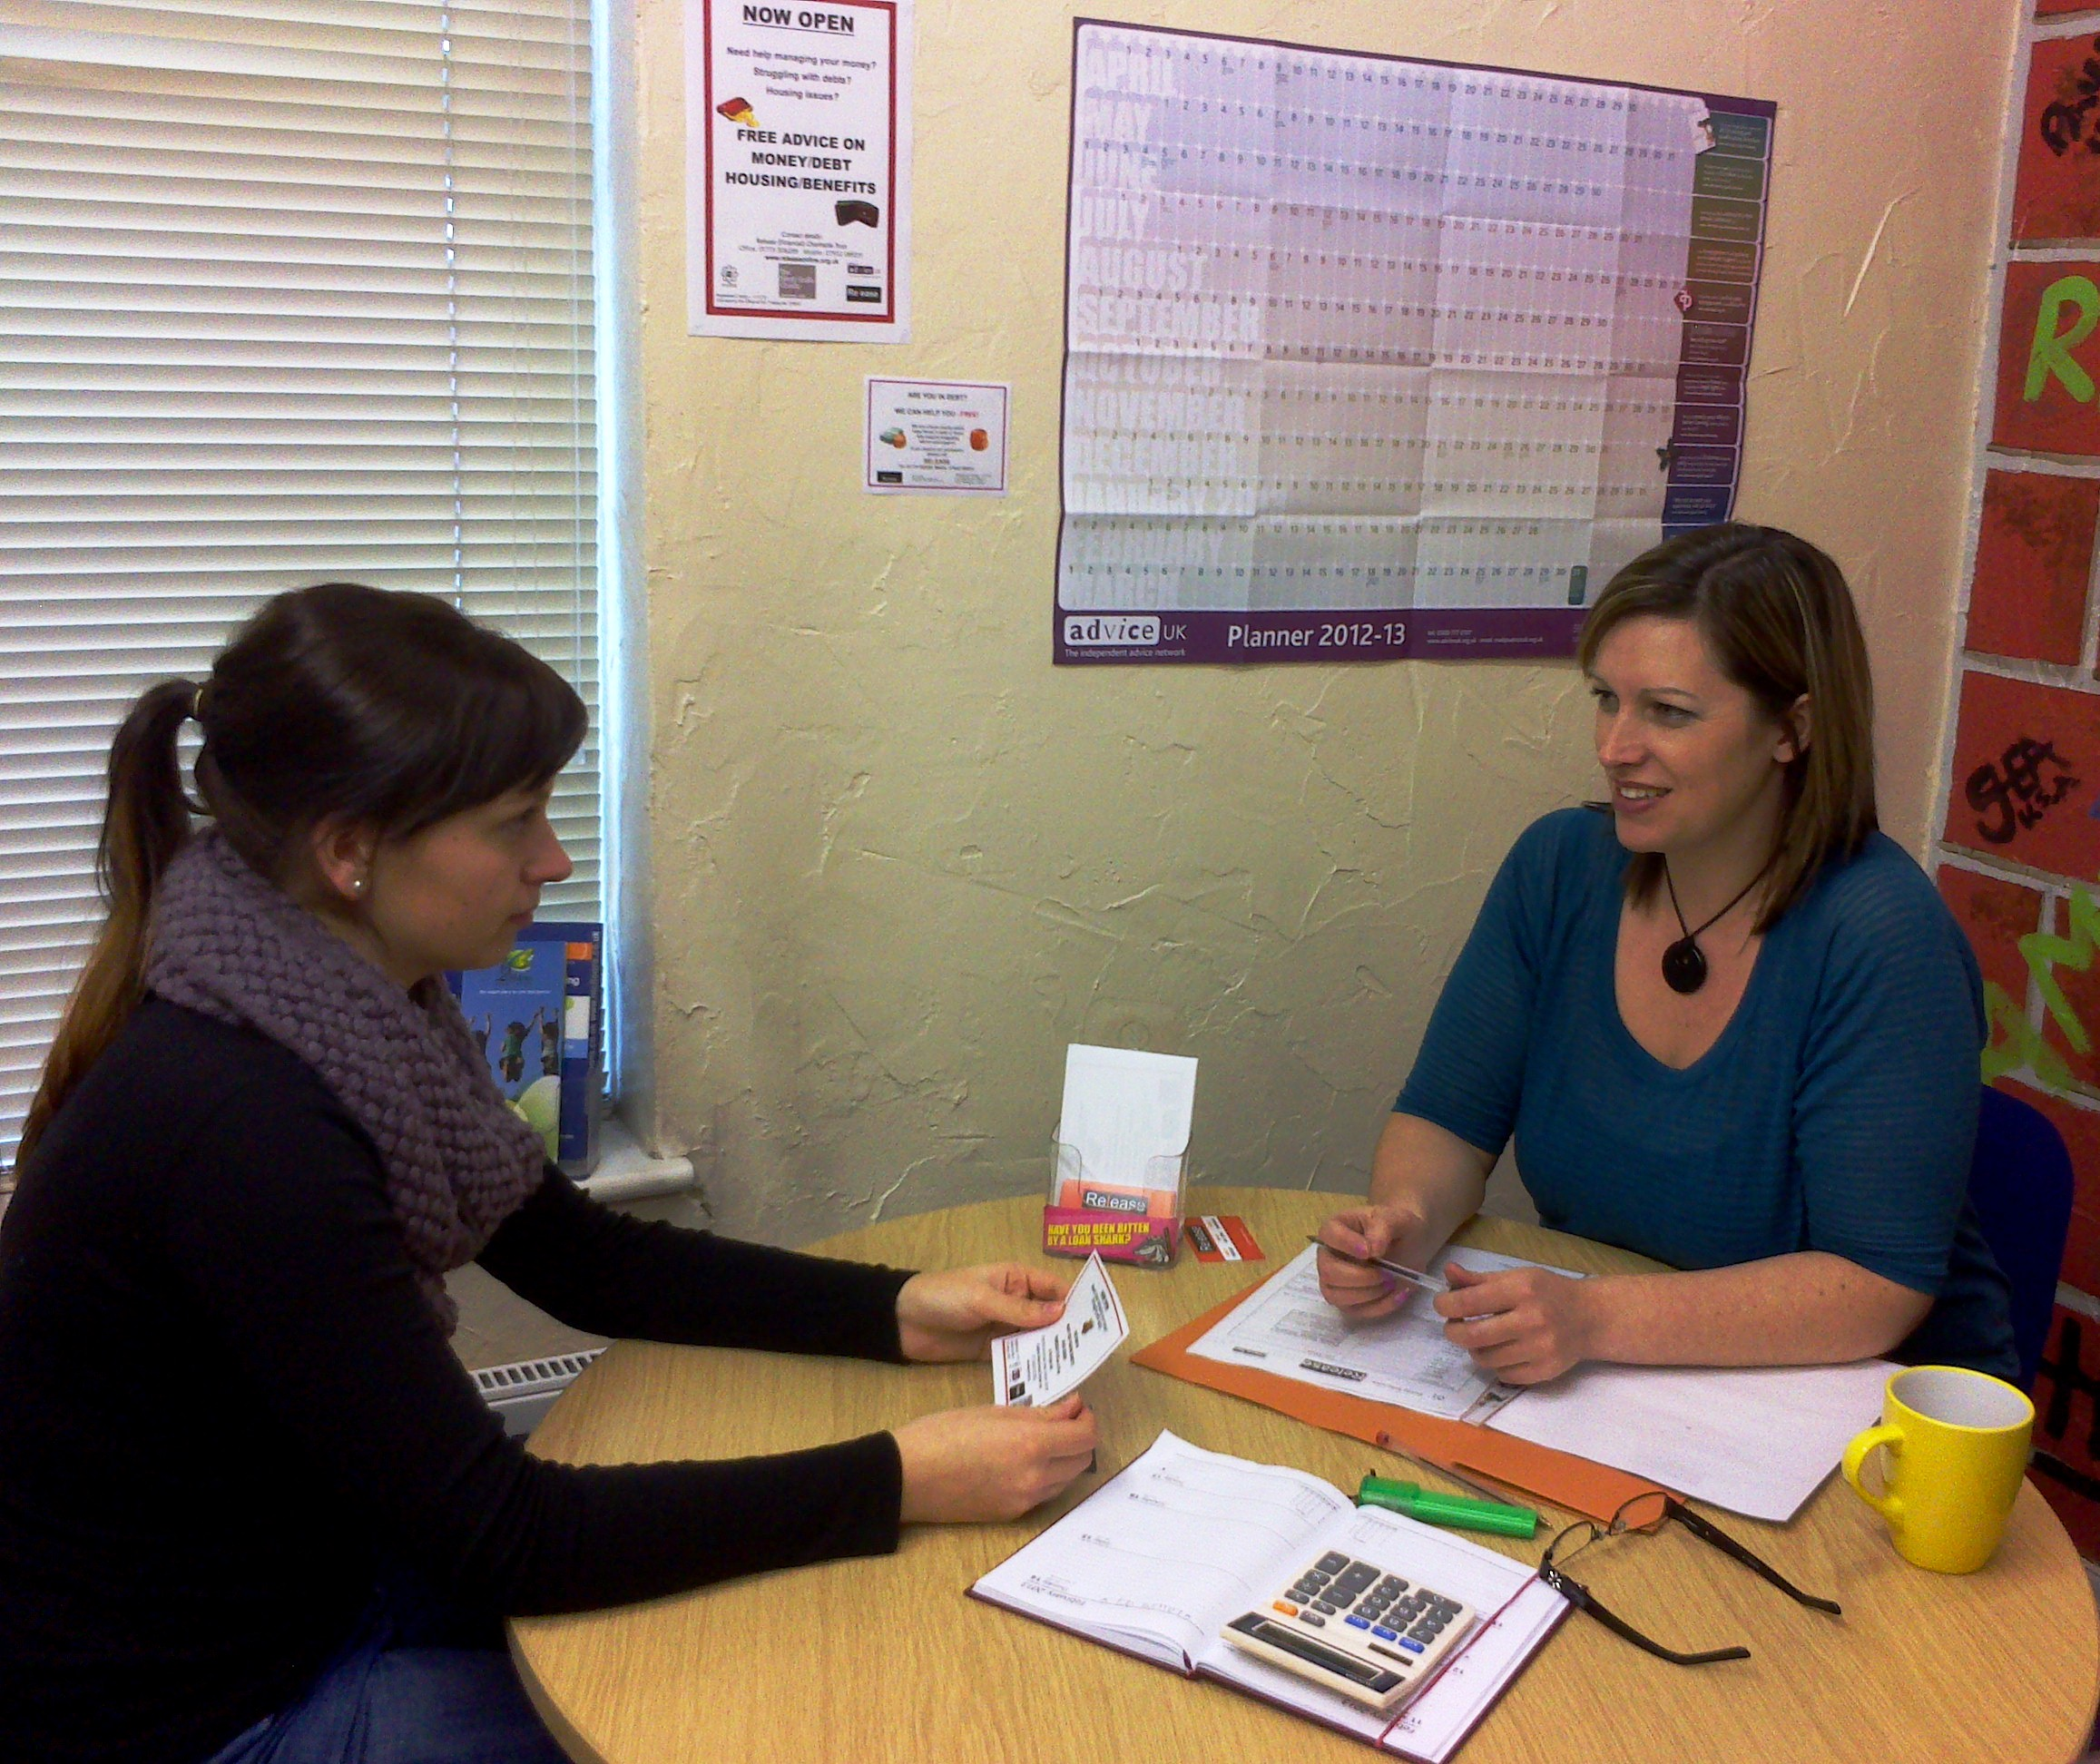
through the process of getting on top of their debts and our budget coaches are available to give people ongoing support and learning skills to be able to manage their money in the future.

We offer free: -
- advice on debt issues
- help and on-going support on managing money in the
future
- if appropriate, point people in the right direction to
get other support/assistance they may require
- friendly helpful team members who will assist people
on a case-by-case/individual basis
- private child friendly meeting room

In certain cases we maybe able to assist people in applying for grants to the likes of Severn Trent Trust Fund, depending on your circumstances and financial position, for help towards water and other arrears and other items including cooker/washer/tumble dryer/fridge/freezer.

We can also offer Debt Relief Orders, if appropriate for people, and refer people to be able to access to the local Trussell Trust food bank.

Please disseminate details of our services through your networks, so that those people who need it are able to access our services and be released from financial bondage.
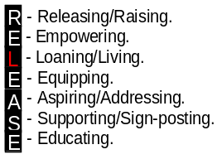

Release (Financial) Charitable Trust
Registered Charity – 1110731
Serving local communities.
Licensed by the Office of Fair Trading No. 576547 - Debt Adjusting/Counselling

39 High Street, South Normanton, Derbyshire, DE55 2BP. Telephone: 01773 306289 or 07932 088331.
www.releaseonline.org.uk email: info@releaseonline.org.uk

